TOGETHER AGAIN
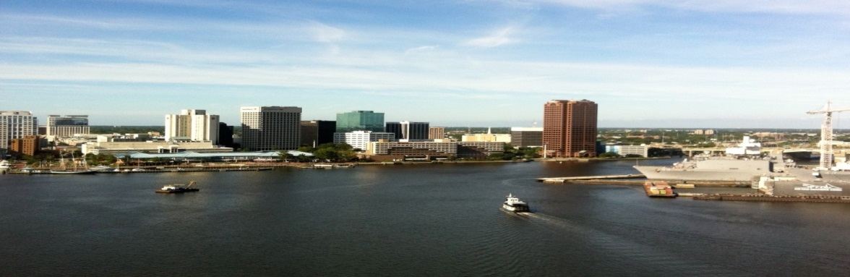

HAIRSTON – GALLANT FAMILY REUNION
SAVE THE DATE
AUGUST 1 – 3, 2014
NORFOLK WATERSIDE MARRIOTT
235 E MAIN STREET
NORFOLK, VIRGINIA 23510
757/627-4200

ROOM RATE = $118 + Tax per night
Last day to book: 7/18/14
I

Website: www.marriott.com/orfws
Enter Check In/Out Dates
Group Code: HGFHGFA
→Click Find
→Click Continue
→Enter Guest Information and continue through

ITINERARY FORTHCOMING

